Task 1

Bug Reports and Test Cases on the website ac.utcluj.ro

Bug Report 1:
Summary: Site search returns “No matches” for words that appear on the site, such as “admitere”
Environment: Desktop, Microsoft Edge, https://ac.utcluj.ro, October 6th, 2026
Steps:
- Open https://ac.utcluj.ro/acasa.html
- Type “admitere” in the search field
- Press Enter
Expected result: Results include the “Admitere licenta”, “Admitere master” and “Admitere doctorat” pages, which exist on the site and contain the word
Actual result: “No matches for admitere”. The website fails to show anything at all.
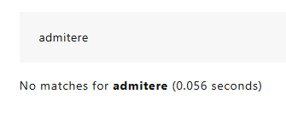
Evidence:
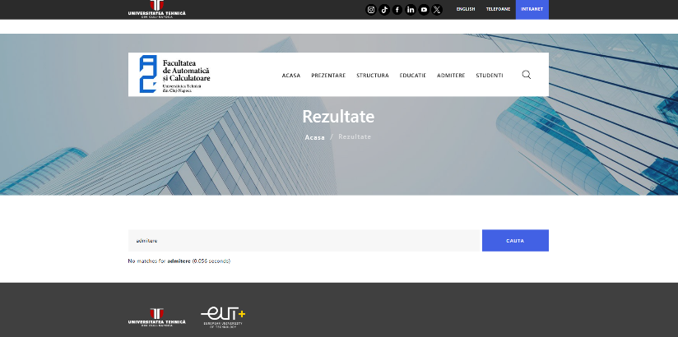

Impact: High

Bug Report 2:
Summary: “English” language switch always opens the English homepage instead of the equivalent page
Environment: Desktop, Microsoft Edge, https://ac.utcluj.ro/admitere-licenta.html, October 6th, 2026
Steps:
- Open https://ac.utcluj.ro/admitere-licenta.html
- Click “English” in the top bar
Expected result: The English version of the same page opens (the website has an equivalent page, https://ac.utcluj.ro/admission/bachelor.html)
Actual result: The English homepage (https://ac.utcluj.ro/home.html) opens, and the user has to find the page again by navigating.
Evidence:
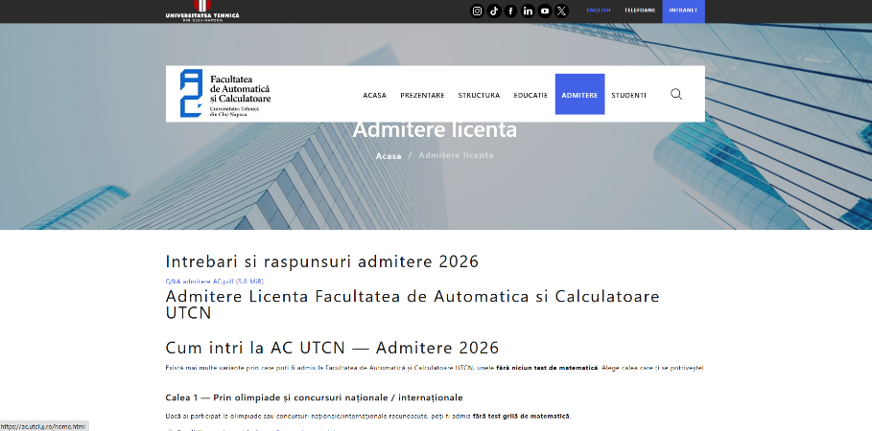

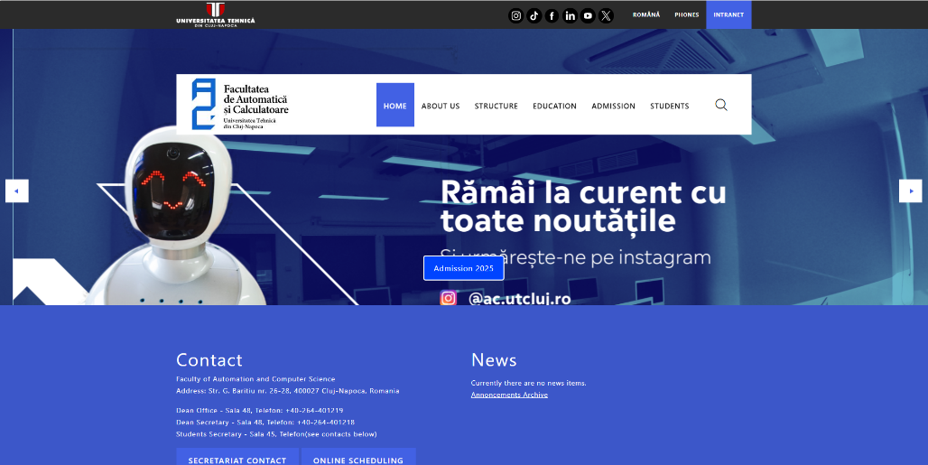

Impact: Medium
Bug Report 3:
Summary: The event on the English homepage links to a 404 error page
Environment: Desktop, Microsoft Edge, https://ac.utcluj.ro/home.html, October 6th, 2026
Steps:
- Open https://ac.utcluj.ro/home.html
- Scroll to the “Events” section and click the title “Automatica si Informatica Aplicata (in limba engleza) certificata EUR-ACE”
Expected results: The event details page opens
Actual results: A 404 error page opens.
Evidence:
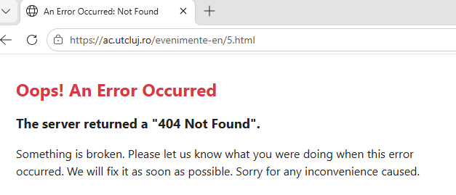
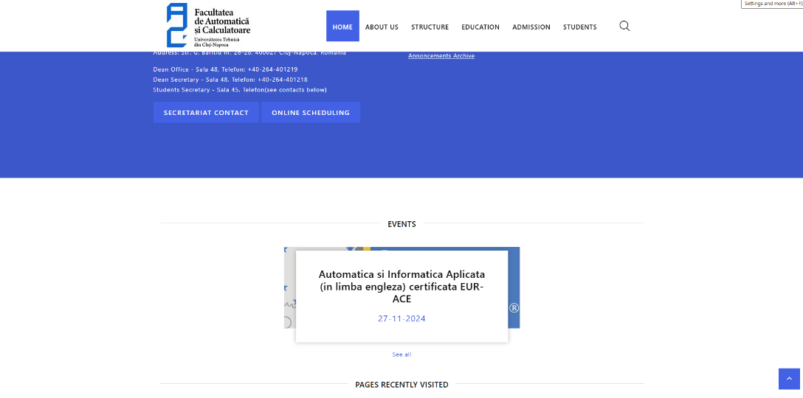

Impact: Low

Test Case TC-001:
Title: Search finds existing pages by keyword
Preconditions:
- The browser is open and connected to the internet
- https://ac.utcluj.ro/acasa.html is accessed
Steps:
- Click the search field
- Type “admitere”
- Hit enter
Expected result: A results page opens listing the pages that contain “admitere”, including “Admitere licenta”, “Admitere master” and “Admitere doctorat”.

Test Case TC-002:
Title: Language switch opens the English version of the current page
Preconditions:
- The browser is open and connected to the internet
- https://ac.utcluj.ro/admitere-licenta.html is accessed
Steps:
- Find the “English” link in the top bar
- Click “English”
Expected results: The English version of the same page opens (https://ac.utcluj.ro/admission/bachelor.html), so the user stays on the same topic in the other language.

Test Case TC-003:
Title: All internal links on the Romanian homepage open without errors
Preconditions:
- The browser is open and connected to the internet
- https://ac.utcluj.ro/acasa.html is accessed
Steps:
- Click each internal link in the header menu, then return to the homepage
- Repeat for every link in the “Anunturi” section, plus “Arhiva Anunturi”
- Repeat for the “Evenimente” section, plus “Afiseaza toate”
- Repeat for the links in the footer that point to ac.utcluj.ro
Expected results: Every link opens a valid page with content. No link leads to a 404 or any other error page.

